Year 5 | Autumn 1 | Autumn 2
Topic | Does the Rainforest Matter?  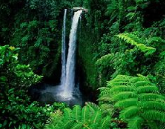 | How did the Second World War affect people at home and abroad?  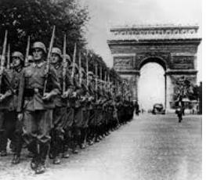
Hook / ‘Wow Moment’  (Topic Launch) | Whole class collaborative rainforest mural artwork. | Trip to National Holocaust Museum
Celebration / Showcase  (Topic Culmination) | Create a mechanical animal | Video Documentary screenings
English | Write to entertain  Write to persuade  Texts: The Great Kapok Tree  Writing outcomes: Alternate version of part of the story – narrative aimed at a different audience  Campaign – persuasive speech, journalistic writing | Write to Reflect  Texts:  Rose Blanche  Diary of Anne Frank  Writing outcomes: Recount and diary entry
Maths | Place Value,  Addition and Subtraction, | Statistics,  Perimeter and Area,  Multiplication and Division
RHE | Being Me | Celebrating Difference
Science | Animals including humans - Life Cycles | Materials and their Properties
History | - | The Second World War (Local + Holocaust)
Geography | The Rainforests of the World
RE | What is the Kindertransport?
PE | Invasion Games - Basketball  Yoga | Dance (1930s-40s Period Dance)  Tennis
Art and Design |  | Henry Moore artist study
Design and Technology | Design a mechanical Animal | -
Computing | Creating media – video production. | Computing systems and networks – systems and searching.
Music | Identify pulse.  Use voice.  Follow more complex graphic notation for rhythms.  Interpret graphic scores,  Begin to follow notation.
Spanish (KS2 only) | Descriptions of eyes and hair  Cultural  All Saints Day in Cadiz (Spain) | Countries  Nationalities  Cultural  Christmas in Cataluña
Additional Enrichment Opportunities |  | Holocaust Centre trip, Potential local visit/visitor  Anti-bullying Week
Key Texts | The Great Kapok Tree  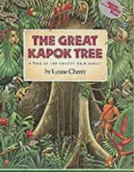 | Rose Blanche, Diary of Anne Frank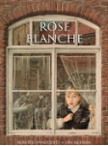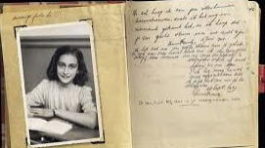
Reading Spine | Varjak Paw  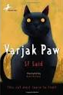 | Varjak Paw

Year 5 | Spring 1 | Spring 2
Topic | A World Turned Upside Down -  The English Civil War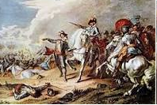 | More than just a vacuum – exploring our Solar System  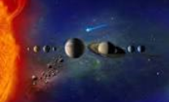
Hook / ‘Wow Moment’  (Topic Launch) | National Civil War Centre (Newark) trip | Trip to National Space Centre – Leicester
Celebration / Showcase  (Topic Culmination) | Assembly / performance | Present Space presentations (assembly or to parents)
English | Write to inform, write to entertain  Texts: Historical Stories, Play Scripts  Writing outcomes: Historical story with a detailed setting and strong character, Play scripts | Write to inform  Texts: Non-fiction texts related to Space exploration  Biographies of scientists/personalities allied to space exploration  Writing outcomes: Non-chronological report.  Biography
Maths | Multiplication and Division,  Fractions | Fractions,  Decimals and Percentages
RHE | Healthy Me | Dreams and Goals
Science | Famous scientists | Space
History | The English Civil War
Geography |  | Marvellous Maps
RE | What can we learn from great leaders and inspiring examples in today’s world?
PE | Dodgeball  Tag Rugby | Gymnastics  Outdoor Adventurous Activities
Art and Design | Pattern and printing | -
Design and Technology | - | Space-themed felt iPad cases
Computing | Programming – selection in physical computing using a microcontroller. | Data and information – flat-file databases.
Music |  | Identify a range of notes.  Layering rhythms  Use body percussion  Perform notes from a major scale.  Introduce chords structure.
Spanish (KS2 only) | The weather | Descriptions of homes and houses  In my house there is/are ...
Additional Enrichment Opportunities | Civil War Centre Trip
Key Texts | Non Fiction Texts relating to the English Civil War, I Coriander  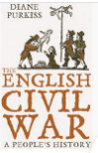 | Non Fiction Texts relating to space, biographies of space figures.  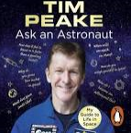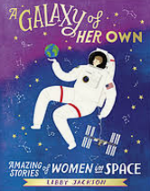
Reading Spine | The Wolves of Willoughby Chase  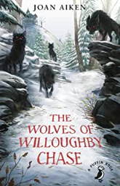 | The Wolves of Willoughby Chase

Year 5 | Summer 1 | Summer 2
Topic | Enough for Everyone? | Into the Labyrinth-  Ancient Greece  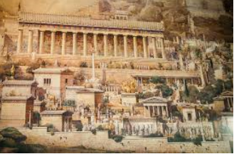
Hook / ‘Wow Moment’  (Topic Launch) | Trip to EcoHouse/visit from Good Weigh? | Partake Theatre Visit
Celebration / Showcase  (Topic Culmination) | Linked to Eco Fair (or our own eco event) | Greek Day
English | Write to discuss  Texts: First News/Newspapers/Journals relating to environmental issues.  Non-fiction environmental/sustainability  Writing outcomes: Journalistic writing (newspaper reports), discussion/ argument | Write to entertain  Texts: Myths, legends and fables (stories from other cultures)-  Narrative poetry/ Chorus and performance poems  Writing outcomes: Write own myth, create own mythological creatures.  Collaborate to write and perform their own narrative poem
Maths | Decimals,  Properties of Shape | Position and Direction,  Converting Units,  Volume
RHE | Relationships | Changing Me
Science | Forces | Animals Including Humans
History | - | Ancient Greece
Geography | Sustainability and Resources
RE | How do people’s beliefs about God, the world and others impact on their lives? | Religion and the individual: What matters to Christians? What is expected of a person following a religion or belief?
PE | Athletics  Cricket | Volleyball  Football
Art and Design | Greek Vases
Design and Technology |  | Greek Food – Snacking like a Greek
Computing | Creating media – introduction to vector graphics. | Programming – selection in quizzes.
Music | Practise and extend learning of:  Knowing a range of notes.  Layering rhythms  Using body percussion  Performing notes from a major scale.  Using chords structure. | -
Spanish (KS2 only) | Inside my room  Prepositions | Spanish Café  Ask for a drink and a snack in a café.  Gaudí
Additional Enrichment Opportunities | Potential Eco Fair / Y5 Eco Fair Selling DT projects | Drama workshop with Partake Theatre  Spanish Day
Key Texts | Sustainability text  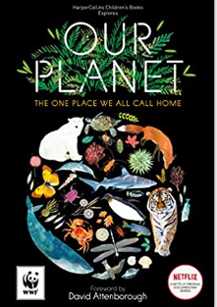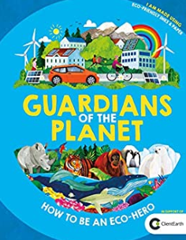 | Aesop’s Fables / Myths  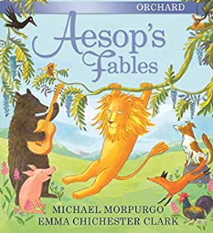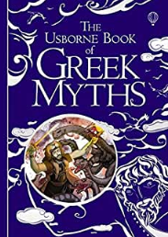
Reading Spine | Wolf Brother  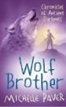 | Wolf Brother

