|  |  |
| --- | --- |
| Key Vocabulary | |
| Christian | A person who follows Christianity. |
| Spiritual | A sense of greater meaning linked to the human spirit or soul, it can also link to a religious belief. |
| Christmas | A Christian festival celebrating the birth of Jesus Christ. |
| Easter | A Christian festival celebrating the resurrection of Jesus Christ. |
| Pentecost | A Christian festival celebrating the descent of the Holy Spirit on the disciples. |
| Harvest festival | A celebration of the annual harvest where people donate gifts, typically of food, to the poor. |
| Commitment | The quality of being dedicated to a cause or belief. |



Year 3 – Beliefs and Questions

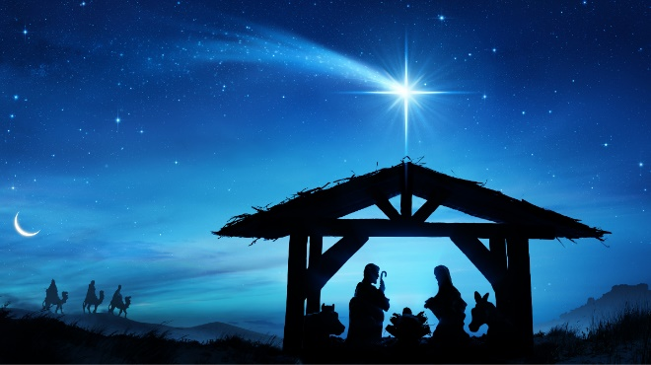

Christmas

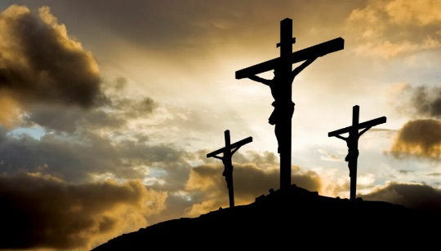

Easter

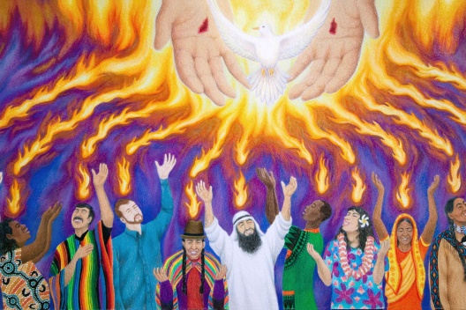

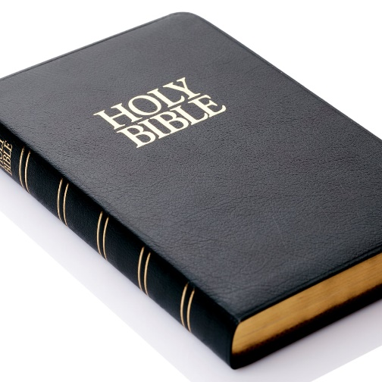

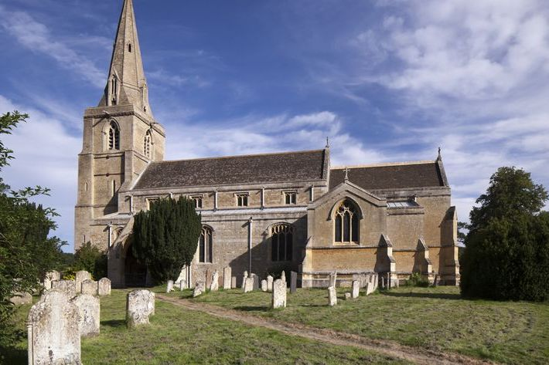

Pentecost

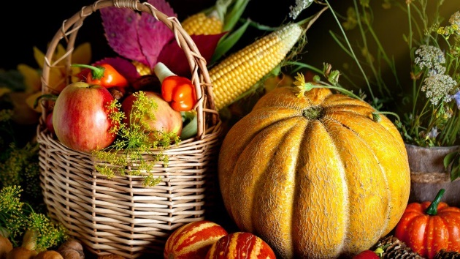

Religious building and book for Christians.

Harvest